**Mauro De Vito**

I'm an iOS Developer, a Web Developer, a Data Analyst, a Passionate about Technology

](mailto:%20mauro.devito@gmail.com)

*\* For a better experience, access to my* [*CV online*](https://maurodevito.github.io/cv/)

## ABOUT

I have been working for TIM (Italian leading telecommunications company) for over 20 years.  
I've gained an extensive experience in the Information Technology, Marketing and Customer Care areas.  
**Since 2012, first for passion and then also for work, I have been following the development of iOS apps.**

iOS Developer, Web Developer, Data Analyst

* **Birthday:**15 July 1974
* **Website:** <https://maurodevito.github.io/cv/>
* **Github:** <https://github.com/maurodevito>
* **Linkedin:** <https://www.linkedin.com/in/mauro-de-vito-54a56733/>
* **Skype:** [maurodevito](skype:maurodevito?chat)
* **Email:** [mauro.devito@gmail.com](mailto:mauro.devito@gmail.com)
* **Phone:**[+39 3356334864](tel:%20+393356334864)

## SKILLS

### **Software Development**

Solid knowledge and experience in iOS app development.  
I have also worked in web development (HTML, JavaScript, CSS, ASP, PHP, SQL), as Alexa Skills developer (NodeJS)

and as a Data Analyst.

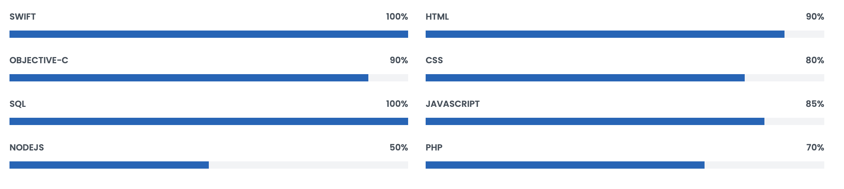

### **Other technical skills**

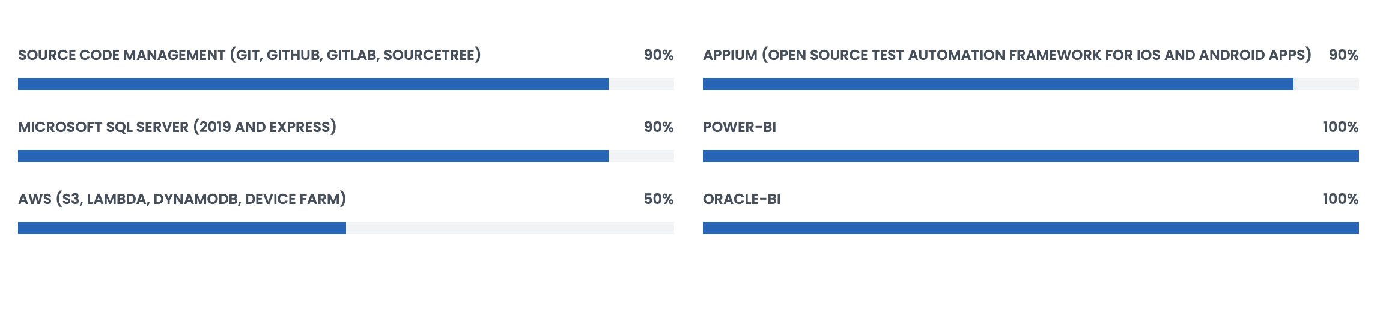

### **Languages**

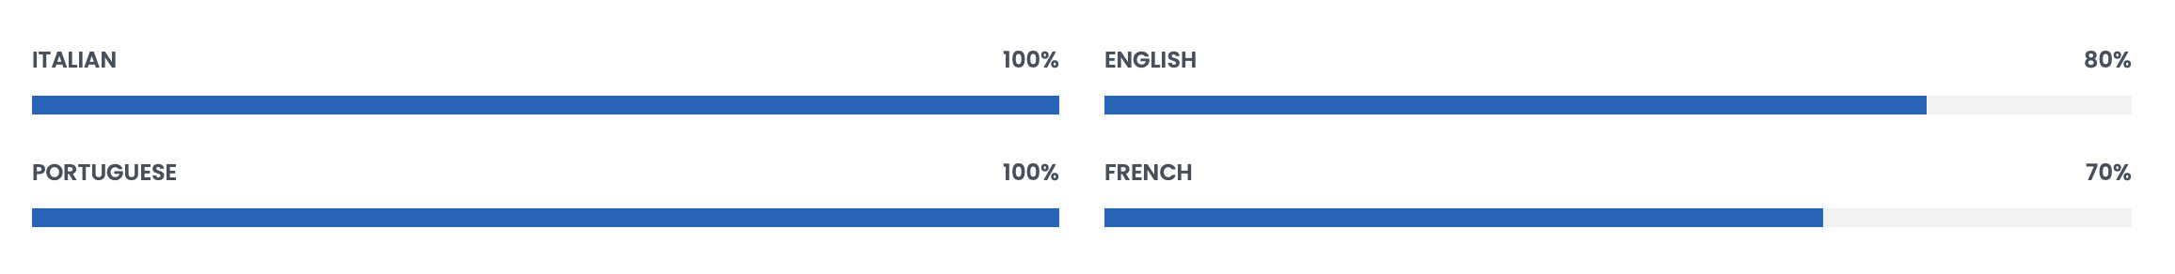

## RESUME

### Professional Experience

#### IOS APP DEVELOPER

##### March 2020 - Present

###### **TIM**

Rome, Italy

* App development MyTim (iOS), app that allows management and control of mobile and landline lines from smartphone.

#### CUSTOMER DATA ANALYST

##### June 2011 - March 2020

###### **TIM**

Rome, Italy

* Data Analysis for the control and improvement of Customer Care
* Data Analysis, control and definition of Caring model
* Multichannel Customer Profiling
* Design and follow-up of technical & functional systems specifications

#### CONSULTANT (PROJECT MANAGER AND SOFTWARE DEVELOPER)

##### April 2010 - December 2010

###### **TIM Brasil**

Rio De Janeiro, Brasil

* Design and elaboration of the technical & functional specifications of the Corporate Intranet
* Planning and Follow UP of the Corporate Intranet project
* Design and Development of Customer Care support systems (web, desktop applications, back-end, database)

#### CONSULTANT (CUSTOMER CARE SPECIALIST AND SOFTWARE DEVELOPER)

##### July 2009 - December 2009

###### **TIM Brasil**

Rio De Janeiro, Brasil

* Analysis and definition of actions to improve Customer Care efficiency (Front-End and Back Office activities management, revision of configurations in the Call Center platform, revision of Customer Care reporting)
* Design and Development of Customer Care support systems (web, desktop applications, back-end, database)
* Organization and training of a Customer Care internal team for the continuation of Office Automation and development activity

#### CONSULTANT (CUSTOMER CARE SPECIALIST AND SOFTWARE DEVELOPER)

##### June 2003 - December 2003

###### **TIM Brasil**

Rio De Janeiro, Brasil

* Customer care full reengineering: caring strategies, caring models, call routing logics.
* Design and Development of Customer Care support systems (web, desktop applications, back-end, database)

#### SOFTWARE DEVELOPER

##### November 1996 - May 2003

###### **TIM**

Naples, Italy

* Design and Development of Customer Care support systems (web, desktop applications, back-end, database)

## PERSONAL PROJECTS

Here are listed some of my **personal projects**.  
All these projects were born out of **hobby, passion, study.**  
Of course work projects are not listed.

**iOS App: Wedding Planner complete**

### Project information

* Immagine che contiene interni

  Descrizione generata automaticamente
* **Project date**: 29 December, 2012
* **Project url**: [Available on tha App Store](https://apps.apple.com/us/app/wedding-wedding-planner-complete/id581776088)
* [](https://apps.apple.com/us/app/wedding-wedding-planner-complete/id581776088)

## Description:

"Wedding - Planner Complete" is your valid ally, simple and complete to organize your wedding.

With "Wedding - Planner Complete" it will be like having a your own personal wedding planner.

- Countdown: configure the data of your Wedding and share the "countdown" by e-mail, facebook or twitter.

- Organizing activities: organize and control all the activities for the preparation of your wedding.

- Contact management: organize and keep on hand all the necessary contacts for the organization of your wedding.

- List guests: create and manage your guest list.

- RSVP: Record the confirmed presence or absence of the guests.

- Seating charts: organize the seating charts of your party.

- Gift List: keep track of gifts received.

- Budget: record and monitor all the expenses and payments of your wedding.

### **iOS App: US Avellino 1912 (Official App)**

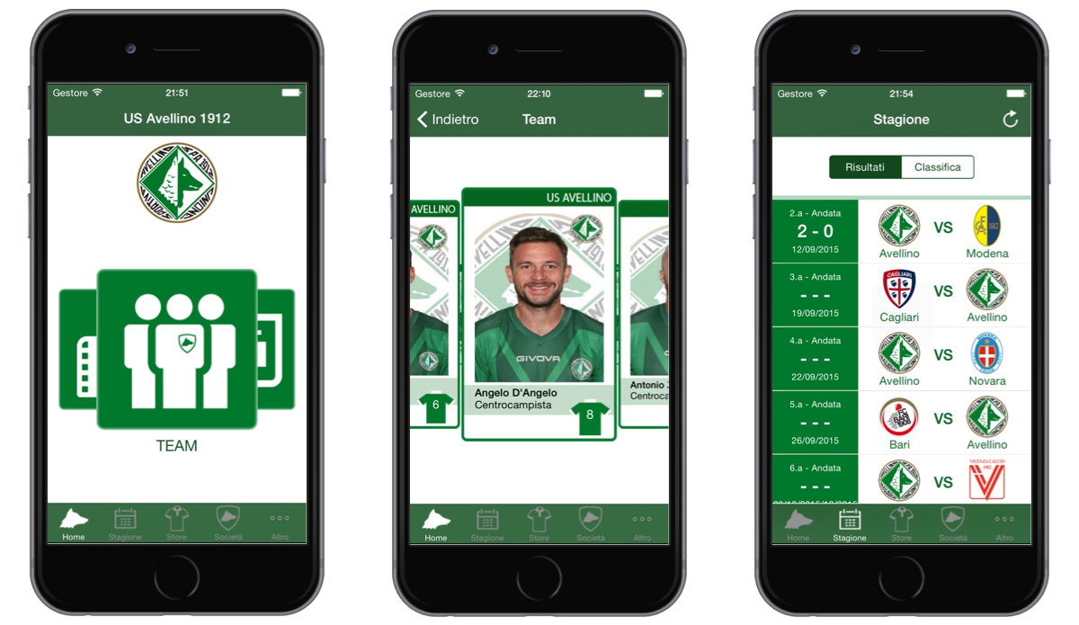

### Project information

* 
* **Project date**: 15 January, 2014
* **Off Line**: 18 July, 2018
* **State**: Due to the change of company, the app has been taken offline. No longer available on the app store

## Description:

Bring the passion of your favorite team to your device: the official app of the US Avellino 1912 football club has arrived!

Thanks to this application you will have free access to news, the calendar and the standings, the Team details, the official store and much more!

Forza Lupi and Forza Avellino !!!

### **iOS App: Santa Claus Game**

### Project information

* 
* **Project date**: 6 December, 2014
* **Project URL**: [Available on tha App Store](https://apps.apple.com/us/app/santa-claus-game/id935826749)
* [](https://apps.apple.com/us/app/santa-claus-game/id935826749)

## Description:

Help Santa Claus delivering gifts.

[how to play: tap to fly]

### **iOS App: Tombolone**

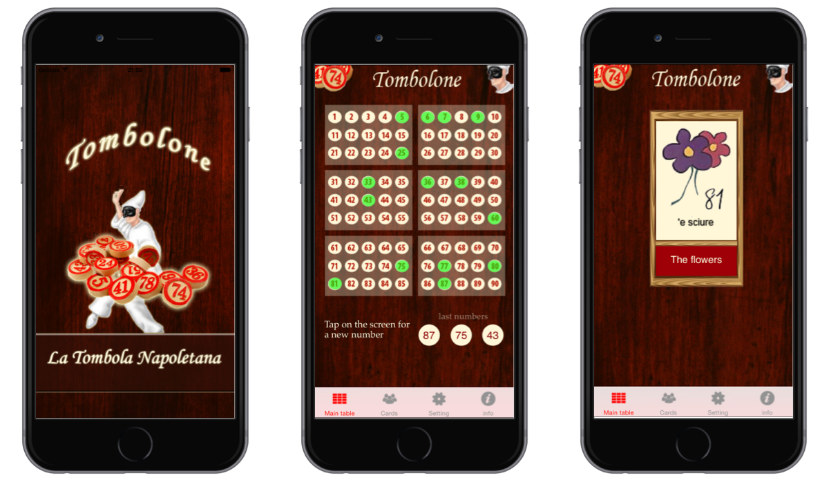

### Project information

* Immagine che contiene testo, segnale

  Descrizione generata automaticamente
* **Project date**: 14 December, 2011
* **Project URL**: [Available on tha App Store](https://apps.apple.com/it/app/tombolone/id488077257?l=en)
* [](https://apps.apple.com/it/app/tombolone/id488077257?l=en)

## Description:

Bingo, the most traditional and classic game for the family, is now even more fun.

- Enjoy the pictures of Neapolitan "Smorfia" (the classical neapolitan interpretation of dreams).

- The app contains a file with the Bingo cards. You can print it and enjoy with your friends and family.

- The numbers extracted are automatically saved. You can pause and resume playing when you want and without risk of having to restart the game.

### **iOS App: Jumply**

### Project information

* 
* **Project date**: 23 November, 2014
* **Off Line**: 01 July, 2016
* **State**: Due to the closure of iAd (Apple iOS Ads SDK) the app is no longer available on the app store. I did not find useful to carry out the project.

## Description:

Bring the passion of your favorite team to your device: the official app of the US Avellino 1912 football club has arrived!

Thanks to this application you will have free access to news, the calendar and the standings, the Team details, the official store and much more!

Forza Lupi and Forza Avellino !!!

### **Alexa Skill: Funny Pranks**

### Project information

* Immagine che contiene clipart

  Descrizione generata automaticamente
* **Project date**: 18 December, 2019
* **Project URL**: [Available Amazon Alexa](https://www.amazon.com/gp/product/B07X6H63QT" \t "_new)
* [](https://www.amazon.com/gp/product/B07X6H63QT)

## Description:

Do you want to make a prank to someone?

Thanks to Funny Pranks, you can plan the reproduction of a noise (for example "ghosts", "barking dog", "earthquake") to scare your friends and not only.

The skill is very simple to use, you just need to open it by saying the phrase "Alexa, open Funny Pranks" and then ask "Play a sound".

For any information, simply say: "Help"

Discover the wide selection of noises divided into 4 categories:

- scary sounds (for example "ghosts", "screams", etc ...)

- animals (eg "lions", "barking dog", etc ...)

- cities (eg "shots", "earthquake", etc ...)

- people (for example "fart", "burp", etc ...)

... and remember to come back every day to add new noises to your collection

Try the "Funny Pranks" skill immediately !!

### **Alexa Skill: Jokes for children**

### Project information

* 
* **Project date**: 18 December, 2019
* **Project URL**: [Available Amazon Alexa](https://www.amazon.it/gp/product/B07P3GB18T)
* [](https://www.amazon.it/gp/product/B07P3GB18T)

## Description:

With Jokes for Children you can have fun with your children, with peace of mind a wide selection of funny jokes and suitable even for the little ones.

The skill is very easy to use, just open it by saying the phrase "Alexa, open Jokes for Kids" and then ask "Alexa, tell me a joke.

## CONTACT

#### Location: Avellino, Italy (available to work remotely or to travel anywhere in the world)

#### Email: mauro.devito@gmail.com

#### Call: +39 3356334864

### Mauro De Vito

*iOS Developer, Web Developer, Data Analyst, Passionate about Technology*

](mailto:%20mauro.devito@gmail.com)